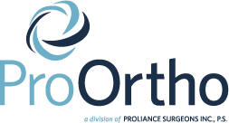

Dr. Koo and Claudia Kalotay PA-C Shoulder Seminar

Hi ________________________________,

Dr. Koo and Claudia host shoulder seminars once a month here at our office in Kirkland located in the lobby at 5:00pm. Claudia will go over what to expect before and after surgeries and have guests from physical therapy offices, Polar Ice, or Donjoy. Both Dr. Koo and Claudia think that this will be beneficial for you and give you a deeper insight into the surgery and how to make the recovery as smooth as possible.
Below is 1 to 2 seminar dates that are available for your attendance that coincide with your surgical date. Please choose one of the seminar dates to attend and notify Jennefer which date you will be able to attend.
You are welcome to notify Jennefer of your chosen date via phone or e-mail.
Seminar:______________________ or Seminar:_______________________
We look forward to seeing you!

Thank you,
Jennefer Gragert | Practice Manager for Dr. Samuel Koo
j.gragert@proliancesurgeons.com | 425.636.4204
ProOrtho | Division of Proliance Surgeons
Office: 425.823.4000 | Fax: 425.821.3550

